ATAR 12 Physical Education Studies

*Biomechanics & Functional Anatomy*

Name: ______________________

*TIME ALLOWED FOR THIS PAPER*

Reading time before commencing work: Five minutes

Working time for paper: Fifty minutes

Section one 10 marks

Section two 28 marks

Section two 15 marks

***TOTAL* 53 marks**

*IMPORTANT NOTE TO CANDIDATES*

* Answer all questions as neatly as possible.
* Raise your hand if you have a question or have finished your test.
* Please NO talking or yelling out!
* It is *your* responsibility to ensure that you do not have any unauthorised notes in the exam room. If you do, hand it to the supervisor immediately.

**SECTION ONE – Multiple Choice (10 marks)**

This section has **10** questions. Answer **all** questions. If you make a mistake, place a cross through that letter, do not erase or use correction fluid. Marks will not be deducted for incorrect answers. No marks will be given if more than one answer is completed for any reason.

Suggested working time: 15 minutes

1. Once a diver is airborne off the 10 metre platform, which of the following can they alter to improve their performance?
   1. angular momentum & moment of inertia
   2. moment of inertia & angular velocity
   3. angular momentum & angular velocity
   4. none of the above
2. An example of where ‘transfer of momentum’ occurs would be
   1. a long jump take-off
   2. a drag flick in hockey
   3. forehand smash in badminton
   4. all of the above

**3.**  The thick myofilament is also known as

1. Z line
2. Myosin
3. Actin
4. I band

**4.**  The fascicles are made up of a bundle of muscle fibres.The fascicles are protected by a dense sheath known as the:

1. endomysium
2. epimysium
3. perimysium
4. cardiomysium

**5**. The part of the motor neuron that receives nerve impulses from other neurons is the

1. cell body
2. axon
3. synapse
4. dendrite

**6.** Upon receiving a neural stimulus to contract a muscle, what happens first?

1. The actin cross-bridges reach out and grab-on to the myosin and begin to oscillate
2. the sarcomere length is reduced
3. the sarcomere length is increased
4. the myosin cross-bridges reach out and grab-on to the actin and begin to oscillate

**7**. Moment of inertia is best described as a body’s:

1. mass
2. resistance to change its motion
3. resistance to change its rotational motion
4. resistance to change its linear motion

**8.** A cricket fast bowler has to generate a great deal of ball velocity by using expert timing within their technique. This is mostly an application of which biomechanical principle?

a) segmental interaction

b) optimal projection

c) balance

d) spin

**9.** During the Paralympics a wheelchair basketballer gets the chair in motion by

1. applying force coupling
2. increasing the range of motion their arms go through
3. applying torque to the wheels with their hands
4. balancing in the chair

**10.** The explanation of how muscles shorten and produce force is known as

a) cross bridge shortening.

b) muscular contraction.

c) muscle fibre activitation.

d) sliding filament theory

**END OF SECTION ONE**

**SECTION TWO – Short Answer (30 marks)**

This section has **five (5)** questions. Answer **all** questions. Write your answers in the spaces provided in this Question/Answer Booklet. Wherever possible, confine your answers to the lines provided. Use a blue or black pen (**not** pencil) for this section.

Spare pages are included at the end of this booklet. They can be used for planning your responses and/or as additional space if required to continue an answer.

* Planning: If you use the spare pages for planning, indicate this clearly at the top of the page.
* Continuing an answer: If you need to use the space to continue an answer, indicate in the original answer space where the answer is continued, i.e. give the page number. Fill in the number of the question(s) that you are continuing to answer at the top of the page.

Suggested working time: 20 minutes

**Question 11 (3 marks)**

Identify **three** characteristics of slow-twitch fibres that enhance their ability to take up and utilise oxygen? Briefly discuss the role of each of these characteristics.

__________________________________________________________________________________________________________________________________________________________________

__________________________________________________________________________________________________________________________________________________________________

**Question 12 (5 marks)**

1. For a drop punt kick, identify **three** biomechanical principles a player can apply to produce maximum velocity on the ball. ( 3 marks)

__________________________________________________________________________________________________________________________________________________________________

__________________________________________________________________________________________________________________________________________________________________

_________________________________________________________________________________

1. Explain **two** reasons why the biomechanical principles identified do not apply to the golf putt or the netball goal shot. (2 marks)

__________________________________________________________________________________________________________________________________________________________________

__________________________________________________________________________________________________________________________________________________________________

**Question 13 (8 marks)**

Using your understanding of the sliding filament theory, Provide **three** factors that explain how contraction occurs in skeletal muscle. Include a diagram in your answer and label **five** parts of the sarcomere.

(8 marks)

__________________________________________________________________________________________________________________________________________________________________

__________________________________________________________________________________________________________________________________________________________________

**Question 14 (5 marks)**

For an athlete’s thought ‘to bounce and catch a tennis ball’ to become a precise motor action, the information must be sent from the brain to the arm and hand muscles.

1. Identify the function of the following elements of the neuromuscular system involved in producing this action.

Axons of the motor neuron

Dendrites of the sensory neuron

Spinal cord (3 marks)

__________________________________________________________________________________________________________________________________________________________________

__________________________________________________________________________________________________________________________________________________________________ __________________________________________________________________________________________________________________________________________________________________

(b) Define the motor unit.

(1 mark)

___________________________________________________________________________________________________________________________________________________________________________________________________________________________________________________

(c) Explain the ‘all-or-nothing’ principle of muscle stimulation.

(1 mark)

__________________________________________________________________________________________________________________________________________________________________

__________________________________________________________________________________________________________________________________________________________________

**Question 15 (4 marks)**

A rugby league player is about to tackle an oncoming opponent. Outline **two** actions the player (tackler) could take to increase stability just before the impact of the tackle (4 marks)

__________________________________________________________________________________________________________________________________________________________________

__________________________________________________________________________________________________________________________________________________________________

**Question 16**

**(3 marks)**

Explain why the motor unit of the eye would have fewer muscle fibres than that of the quadriceps group.

__________________________________________________________________________________________________________________________________________________________________

__________________________________________________________________________________________________________________________________________________________________

**Section Three: Extended answer (15 MARKS)**

This section contains one (1) question. Write your answer in the spaces provided.

Spare pages are included at the end of this booklet. They can be used for planning your responses and/or additional space if required to continue an answer.

* Planning: if you use the spare pages for planning, indicate this clearly at the top of the page.
* Continuing an answer: If you need to use the space to continue an answer, indicate in the original space where the answer is continued, i.e. give the page number. Fill in the number of the question that you are continuing to answer at the top of the page.

Suggested working time: 20 minutes.

**Question 16 (15 marks)**

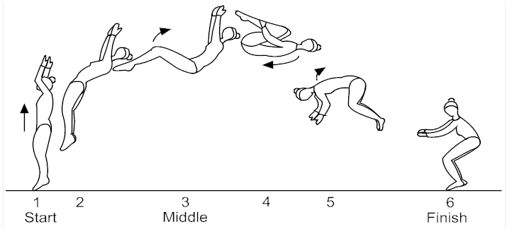

Samantha Spinalotski (pictured above performing a backflip from a standing position) has been selected to represent Australia in the Gymnastics world championships.

1. Referring to the diagram above, discuss how the gymnast’s moment of inertia, angular momentum and radius of rotation enable her to successfully complete a backflip (divide the movement into three sections to structure your response). Explain why it would be harder for Samantha to successfully complete a backflip from a standing start in a layout position (as opposed to a tuck position). (12 marks)

__________________________________________________________________________________________________________________________________________________________________

__________________________________________________________________________________________________________________________________________________________________

__________________________________________________________________________________________________________________________________________________________________

__________________________________________________________________________________________________________________________________________________________________

__________________________________________________________________________________________________________________________________________________________________

__________________________________________________________________________________________________________________________________________________________________

__________________________________________________________________________________________________________________________________________________________________

__________________________________________________________________________________________________________________________________________________________________

__________________________________________________________________________________________________________________________________________________________________ ______________________________________________________________________________________________________________________________________________________________________________________________________________________________________________________________________________________________________________________________________________________________________________________________________________________________________________________________________________________________________________________________________________________________________________________________________________________________________________________________________________________________________________________________________________________________________________________________________________________________________________________________________________________________________________________________________________________________________________________________________________________________________________________________________________________________________________________________________________________________________________

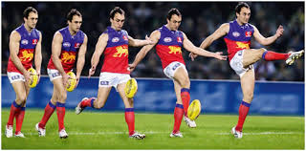

1. The position of the leg when of kicking an AFL ball as shown in the image above is considered to result in an optimal muscle length. Explain the force-length relationship of muscle contraction with respect to a very flexed, middle and extended knee joint. (3 marks)

__________________________________________________________________________________________________________________________________________________________________

__________________________________________________________________________________________________________________________________________________________________ ____________________________________________________________________________________________________________________________________________________________________________________________________________________________________________________________________________________________________________________________________

**END OF TEST**